YOLOv8
This document explains how to set up, train, and evaluate YOLOv8 using a custom dataset. The following sections are included:
- Introduction
- Installation & Setup
- Model Architecture
- Training on a Custom Dataset
- Model Evaluation

1. Introduction
What is YOLOv8?
YOLOv8 (You Only Look Once, Version 8) is the latest iteration of the YOLO family of object detection models, developed by Ultralytics. It is an advanced real-time object detection model that supports classification, segmentation, and object tracking.
Why use YOLOv8?
- Fast & Accurate: Achieves high-speed object detection with minimal loss of accuracy.
- Ease of Use: Provides an intuitive Python API for training, inference, and evaluation.
- Multi-tasking: Can perform object detection, segmentation, and classification.
- Pretrained Weights: Supports transfer learning from pretrained models for faster training.
Applications of YOLOv8
- Autonomous Vehicles: Detecting pedestrians, traffic signs, and obstacles.
- Retail & Surveillance: Tracking customers and detecting suspicious activities.
- Medical Imaging: Identifying anomalies in medical scans.
- Industrial Automation: Inspecting products on assembly lines.

2. Installation & Setup
Install Dependencies
Install the required Python libraries for YOLOv8.
!pip install ultralytics
Import YOLOv8 and Verify Installation
After installation, verify that the Ultralytics library is correctly installed.
from ultralytics import YOLO
# Check YOLO installation
print(YOLO.__version__)

3. Model Architecture
YOLOv8 follows a modular structure with the following key components:
Backbone
- Extracts deep features from input images.
- Uses CSPDarknet as the feature extractor.
Neck
- Merges features at different scales to improve object detection.
- Uses Path Aggregation Network (PANet) to enhance multi-scale predictions.
Head
- Final prediction layers that output bounding boxes, class scores, and confidence scores.
- Uses Decoupled Head for improved accuracy.
Activation Functions and Improvements
- SiLU (Swish) Activation: Provides better convergence during training.
- Anchor-Free Prediction: Simplifies object detection by removing the need for anchor boxes.
- Efficient Decoding: Faster and optimized object detection.

4. Training on a Custom Dataset
Step 1: Extract the Dataset
Extract the dataset from a ZIP file and organize it.
import zipfile
import os
# Path to the ZIP file
zip_path = '/content/battery detection 2.v3i.yolov8.zip' # Update the path
# Destination folder
extract_dir = '/content/battery-detection/'
# Unzip dataset
with zipfile.ZipFile(zip_path, 'r') as zip_ref:
zip_ref.extractall(extract_dir)
print("Dataset unzipped successfully!")

Step 2: Configure Data File (data.yaml)
Define the dataset structure in a YAML configuration file.
train: '/content/battery-detection/train' # Path to training images
val: '/content/battery-detection/valid' # Path to validation images
nc: 3 # Number of classes
names: ['drycell', 'coincell', '9V'] # Class names

Step 3: Train the YOLOv8 Model
- Load the YOLOv8 model with pretrained weights.
- Train the model on the custom dataset.
from ultralytics import YOLO
# Load the YOLOv8 model (transfer learning)
model = YOLO('yolov8s.pt') # Uses a small pretrained YOLOv8 model
# Train the model on the custom dataset
model.train(data='/content/battery-detection/data.yaml', epochs=10, imgsz=640)
This command:
- Loads a pretrained YOLOv8 model (yolov8s.pt).
- Trains it for 10 epochs on images of 640x640 resolution.
- Uses data specified in data.yaml.

Step 4: Validate the Model
Once training is complete, evaluate the model on validation data.
metrics = model.val()
print(metrics)
The expected output includes metrics like:
- mAP50 (Mean Average Precision at IoU 0.50)
- mAP50-95 (Mean Average Precision across IoU thresholds)
- Precision and Recall scores

5. Model Evaluation
Checking mAP & Model Summary
The model evaluation summary provides details about performance.
Model summary (fused): 168 layers, 11,126,745 parameters, 0 gradients, 28.4 GFLOPs
val: Scanning /content/battery-detection/valid/labels.cache... 47 images, 0 backgrounds, 0 corrupt: 100%|██████████| 47/47 [00:00<?, ?it/s]
Class Images Instances Box(P R mAP50 mAP50-95): 100%|██████████| 3/3 [00:01<00:00, 2.31it/s]
all 47 113 0.971 0.972 0.992 0.906
9V 20 40 1 0.915 0.987 0.925
coincell 7 16 0.966 1 0.995 0.909
drycell 20 57 0.945 1 0.993 0.883

Running Inference on New Images
Use the trained model to make predictions on test images.
import matplotlib.pyplot as plt
from ultralytics import YOLO
# Load the trained model
model = YOLO('/content/trained_model.pt') # Path to saved model
# Folder containing test images
new_images_folder = '/content/battery-detection/test/images'
# Run inference on all test images
results = model.predict(source=new_images_folder, imgsz=640)
# Set display size (width x height in inches)
display_size = (10, 8)
# Loop through results and visualize
for result in results:
annotated_img = result.plot() # Annotate image
plt.figure(figsize=display_size)
plt.imshow(annotated_img)
plt.axis('off') # Hide axes
plt.show()

Visualizing Predictions
The model will output images with detected objects and their bounding boxes.
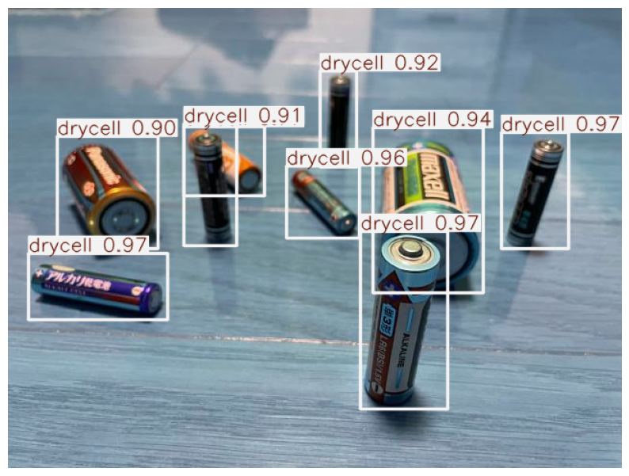
Inference Speed: ~2.4 images/second.

